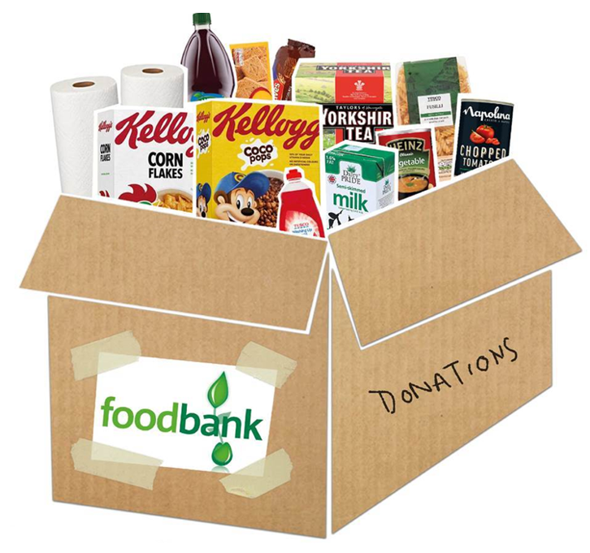


Please bring any donations for Luton food bank to the reception area.
We will be taking the parcel to them on 11th December.

OUR SHOPPING LIST
The items we most need at the moment are:
Tinned Rice Pudding and Tinned Custard
Tinned Meat and Tinned Fish
Tinned Veg, Tinned tomatoes and Tinned Fruit
Fruit Juice (Carton)
Dried rice (500g)
Soup
Milk (UHT)
Baked beans
Tinned pasta in sauce
Sauce for pasta
Breakfast cereal
Tea bags

Biscuits (single packs)
Sugar (500g)

